Christ the King Sunday November 23, 2025
Prairieland Parish
As we unite in worship today, we extend a warm welcome to each one present. May we together experience the presence of God
+++++++++++++++++++++++++++++++++++++++++++++++++.
We Gather to Prepare Our Hearts to Meet Our Lord

Prelude
Welcome
Announcements

CALL TO WORSHIP
It is done.
God has always been in charge—
yesterday and today.
Even when things seem out of control,
God’s reign is on its way.
Let us prepare the way for God.

Opening Prayer
Lord Jesus, you stretched out your arms of love on the hard wood of the cross,
that all people might come within the reach of your saving embrace.
Clothe us in your Spirit, that we, stretching out our hands in loving service for others,
may bring those who do not know you to an awareness and love of you;
who with the Father and the Holy Spirit live and reign, One God forever! Amen!

*HYMN OF PRAISE FWS #2113 “Lamb of God”

We Hear God’s Word

Gospel Reading………………………………………………………… Luke 23:33-43
The Word of God for the People of God, Thanks be to God!

CHILDREN’S SERMON

FAITH HYMN UMH #206 “I Want to Walk as a Child of the Light”

“Message”
Joys/Concerns

PRAYER FOR THE DAY
Lord’s Prayer

Offertory
Doxology

Offertory Prayer

Departing Hymn UMH #261 “Lord of the Dance”

Benediction

*POSTLUDE

November Prairieland Parish Events

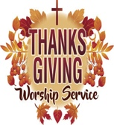
Prairieland Parish wide Worship Service Opportunity

Hosted by: Zion UMC, Sargeant, MN

Date: 26^{th.} Time: 6:30pm
All are invited to come and give thanks to the One whom has blessed us in so many ways!
++++++++++++++++++++++++++++++++++++++++++++
Advent Begins on Sunday, November 30th
Each week readers from the congregation will start with a liturgy of advent
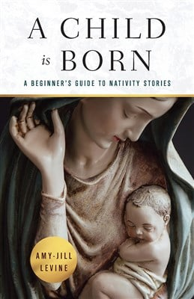
++++++++++++++++++++++++++++++++++++++++++++

Prairieland Parish
Is joining Together for a 4-week book study titled:
“A Child is Born” by Amy-Jill Levine
We will meet in-person Tuesday’s @ 2 pm
@ United Church of Grand Meadow
December 2nd, December 9th, December 16th, December 23rd
++++++++++++++++++++++++++++++++++++++++++
Zoom Study Opportunity
to be led by Bishop Lanette Plambeck
In this study, United Methodists across the Dakotas and Minnesota will gather via zoom on Monday Evenings with Bishop Lanette
Weekly discussions will be held via Zoom on Monday evenings,
Dec 1st-Dec. 22nd, 7-8:15 p.m.

The Zoom link will be provided @ minnesotaumc.org as the first discussion date draws near
You may go on-line to purchase your own book or reserve a book with Pastor Jon or Bridget for $14.00

